ELITE PREP
SAT Analysis Report & Improvement Plan

STUDENT Sumin Yoon | 6 Diagnostic Tests · DSAT-01-B → DSAT-06-A

Score Trajectory Overview
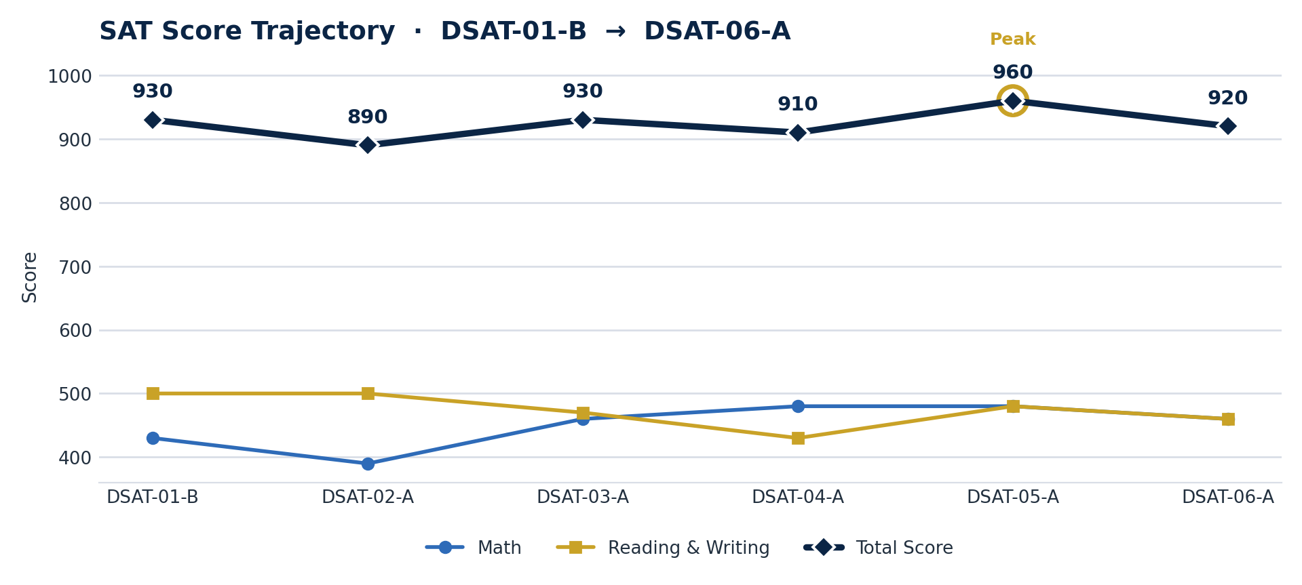
Total score rises and falls across the six diagnostics, peaking at 960 on DSAT-05-A; Math and Reading & Writing shown for context.

Based on the diagnostic test results provided for Sumin Yoon across 6 practice tests (DSAT-01-B, DSAT-02-A, DSAT-03-A, DSAT-04-A, DSAT-05-A, DSAT-06-A), this report presents a detailed analysis of the student's performance, key weaknesses, and a targeted study plan.

Diagnostic Report Overview
SCORE RANGE  890 – 960  Total, across 6 tests | PEAK SCORE  960  DSAT-05-A | LATEST SCORE  920  DSAT-06-A

Student Name: Sumin Yoon
Test Trajectory: 930 (DSAT-01-B) → 890 (DSAT-02-A) → 930 (DSAT-03-A) → 910 (DSAT-04-A) → 960 (DSAT-05-A) → 920 (DSAT-06-A)
Performance Trend: Sumin's total score has shown slight fluctuation, starting at 930 and ending at 920, with a peak of 960 on DSAT-05-A. Math scores were initially 430, dipped to 390, then showed some improvement to plateau around 460–480. Reading and Writing scores were volatile, starting at 500, dipping significantly to 430 on DSAT-04-A, and ending at 460. Omitted questions were minimal across all tests, indicating an attempt to answer all questions.
Key Weaknesses & Curricular Solutions
1. Math: Advanced Math
CRITICAL WEAKNESS

Specific Skills Lacking: Sumin consistently struggles with Advanced Math concepts, scoring 58% on DSAT-01-B, dropping to 25% on DSAT-03-A, and remaining low at 33% on DSAT-06-A. This indicates a significant gap in understanding higher-level algebraic functions, polynomials, and their graphical representations. The student likely faces challenges in identifying key features from quadratic equations, manipulating polynomials, and interpreting function graphs, potentially due to common mistakes like failing to identify vertex/roots or misunderstanding tangency.
Curriculum Chapters
- Chapter 32: Quadratic Equations
- Chapter 35: Polynomials
- Chapter 36: Graphs of Functions
- Chapter 37: Nonlinear Equations in Context
2. Math: Geometry and Trigonometry
FOUNDATIONAL GAP

Specific Skills Lacking: Performance in Geometry and Trigonometry is highly inconsistent and frequently low, with scores of 38% on DSAT-01-B, 17% on DSAT-03-A, and 38% on DSAT-05-A. This suggests a foundational gap in basic geometric principles, including properties of lines and angles, right triangle theorems, and area/volume calculations. The student may be making common mistakes such as trusting non-scale diagrams, failing to memorize special ratios for right triangles, or incorrectly applying area and volume formulas.
Curriculum Chapters
- Chapter 15: Lines and Angles
- Chapter 26: Right Triangles
- Chapter 28: Area and Volume
- Chapter 29: Circles
3. Reading and Writing: Standard English Conventions
CRITICAL WEAKNESS

Specific Skills Lacking: Sumin's performance in Standard English Conventions is extremely volatile and concerning, with scores ranging from 71% on DSAT-02-A to a critical 0% on DSAT-06-A and 21% on DSAT-04-A. This indicates a severe and inconsistent grasp of fundamental grammar and punctuation rules. The student likely struggles with identifying and correcting errors related to sentence structure (clauses), subject-verb agreement, proper use of possessives, and various punctuation marks, often relying on what “sounds right” rather than strict grammatical rules.
Curriculum Chapters
- Chapter 6: Clauses
- Chapter 9: Subject-Verb Agreement / Collective Nouns
- Chapter 13: Possessive Nouns and Possessive Determiners
- Chapter 21: Punctuation
4. Reading and Writing: Craft and Structure
FOUNDATIONAL GAP

Specific Skills Lacking: The student consistently scores in the low to mid-50s for Craft and Structure, with a notable dip to 33% on DSAT-02-A. This suggests difficulty in analyzing how authors use language, word choice, and text organization to achieve specific purposes. Sumin may be struggling with interpreting words in context beyond their primary definitions or identifying the main purpose of a text versus the function of specific parts.
Curriculum Chapters
- Chapter 12: Words in Context
- Chapter 16: Text Structure and Purpose

Tutoring Recommendations & Logistics
TARGET SCORE  1200 – 1250  Math 600–625 · RW 600–625 | TOTAL HOURS  24 Hours  16 Math / 8 RW | FREQUENCY  2 / week  1.5 hrs per session

Goal Breakdown: The goal is to achieve a Math score of 600–625 and a Reading & Writing score of 600–625, focusing on building foundational knowledge to ensure consistent performance.
Hours Split: 16 Hours Math / 8 Hours Reading & Writing. This split prioritizes Math due to its consistently lower scores and the presence of critical foundational gaps in Advanced Math and Geometry.
Week-by-Week Study Plan

Week | Focus | Curriculum
Week 1 | Foundational Geometry & Grammar | Math: Ch.15 Lines and Angles; Ch.26 Right Triangles  RW: Ch.6 Clauses; Ch.13 Possessive Nouns and Possessive Determiners
Week 2 | Intermediate Geometry & Subject-Verb Agreement | Math: Ch.28 Area and Volume; Ch.29 Circles  RW: Ch.9 Subject-Verb Agreement / Collective Nouns
Week 3 | Quadratic & Polynomial Foundations | Math: Ch.32 Quadratic Equations; Ch.35 Polynomials  RW: Ch.12 Words in Context
Week 4 | Advanced Functions & Punctuation Mastery | Math: Ch.36 Graphs of Functions; Ch.37 Nonlinear Equations in Context  RW: Ch.21 Punctuation
Week 5 | Data Analysis Basics & Text Purpose | Math: Ch.10 Ratios, Rates, and Proportions; Ch.12 Percentages  RW: Ch.16 Text Structure and Purpose
Week 6 | Data Analysis & RW Grammar Review | Math: Ch.17 Measures of Center; Ch.23 Scatterplots  RW: Comprehensive review of Standard English Conventions, focusing on application in practice questions
Week 7 | Timed Drills & Strategy | Math: Timed practice on mixed problem sets from all covered categories, emphasizing error analysis and efficient problem-solving strategies  RW: Timed practice on full Reading and Writing sections, focusing on pacing, question types, and applying learned grammar and comprehension strategies
Week 8 | Full Practice Test Review | Math: Detailed review of a full practice test, identifying remaining weak areas and reinforcing concepts  RW: Detailed review of a full practice test, analyzing incorrect answers and refining strategies for accuracy and speed

Elite Prep · SAT Analysis Report & Improvement Plan

